Accessing isolved via your smartphone
There is an app via the App Store/Play Store, but we suggest not using it, use these instructions instead
Click here for Android Instructions
- iPhone Instructions
  - Delete all existing isolved apps off of your phone if you have any installed
    - This step is VERY important as it ensures that the next steps go smoothly.
  - On your phone, open SAFARI browser go to https://payrolldept.myisolved.com/cloudservice
Login with your existing username and password (contact your administrator if you are not yet registered).
  - Once logged in, click on the “Share” icon at the bottom of the screen
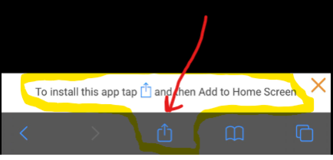
  - Click on “Add to Home Screen”
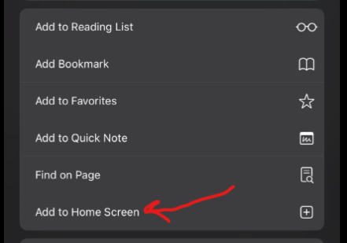

  - Name it what you want and click “Add”
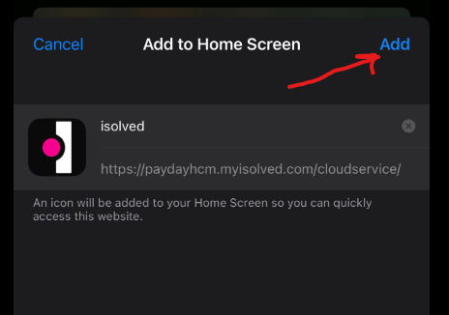

  - It will add this icon to your home screen
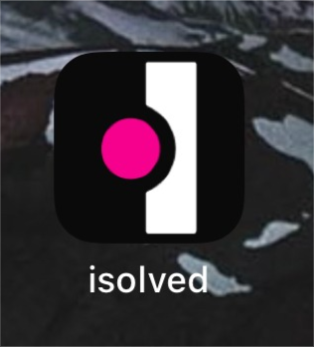
  - Allow the notifications by clicking “Subscribe” and then “Allow”
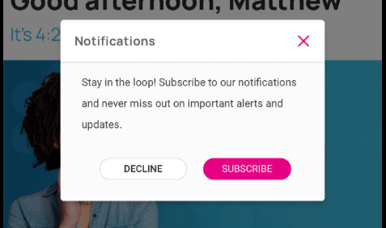
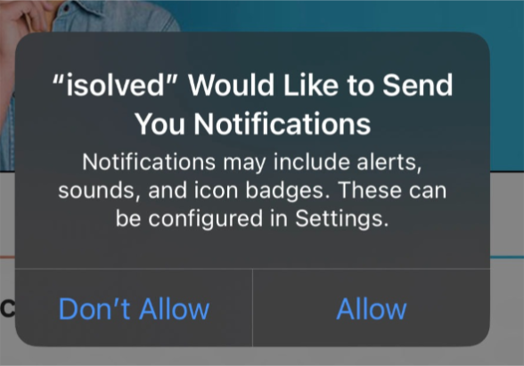
  - Log in and then the app should stay logged in for clocking in and out

- Android Instructions
  - Delete all existing isolved apps off of your phone if you have any installed
    - This step is VERY important as it ensures that the next steps go smoothly.
  - On your phone, open your CHROME browser and go to https://payrolldept.myisolved.com/cloudservice
ogin with your existing username and password (contact your administrator if you are not yet registered).
  - Click on the 3 dots at the top right of the screen
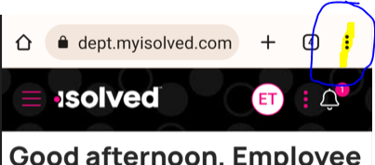

  - Click on “Install App”
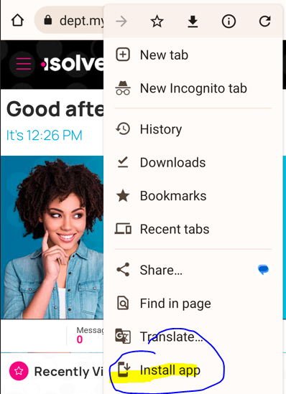

  - Say “Add” when prompted to “Add to home screen”
  - It will add this icon to your home screen
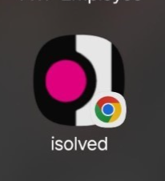
  - When you click on the icon, isolved will open with you already logged in, and the app should stay logged in (unless you change your password).

